INTERFACE DESIGN
What
The Interface Design phase focuses on creating a user-friendly ServiceNow interface through which users can submit Network Request service requests.
The interface consists of:
- A dedicated Network Request Service Catalog item.
- Request-specific variables.
- Multiple-choice and text-based inputs.
- A reusable Variable Set for requester information.
- Auto-population of user information where applicable.
- Mandatory and read-only controls to improve data quality.
The design is intended to make request submission simple while ensuring that the information required for downstream approval and fulfilment is captured consistently.
Why
A well-designed request interface reduces incomplete or incorrect submissions and improves the overall user experience.
The interface is designed to:
- Provide a standardized network-request submission process.
- Capture all required request information.
- Reduce repetitive data entry.
- Automatically populate known user information.
- Improve consistency of request data.
- Support subsequent approval and fulfilment automation.
Activity 1 – Creation of Service Catalog Item
What
Create a Service Catalog item named Network Request that acts as the primary entry point for users requesting network services.
Why
A dedicated catalog item gives users a centralized and standardized method for submitting network requests instead of relying on informal or manual communication.
How
- Open the Application Navigator.
- Navigate to:
All → Service Catalog → Maintain Items
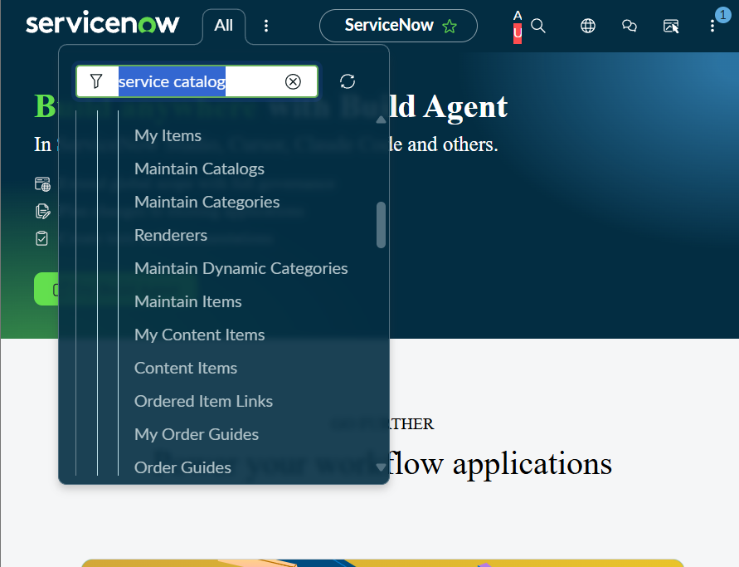
- Click New.
- Enter:
Field | Value
Name | Network Request
Catalog | Service Catalog
Category | Network
Short Description | Network request Management
- Review the information.
- Click Save.
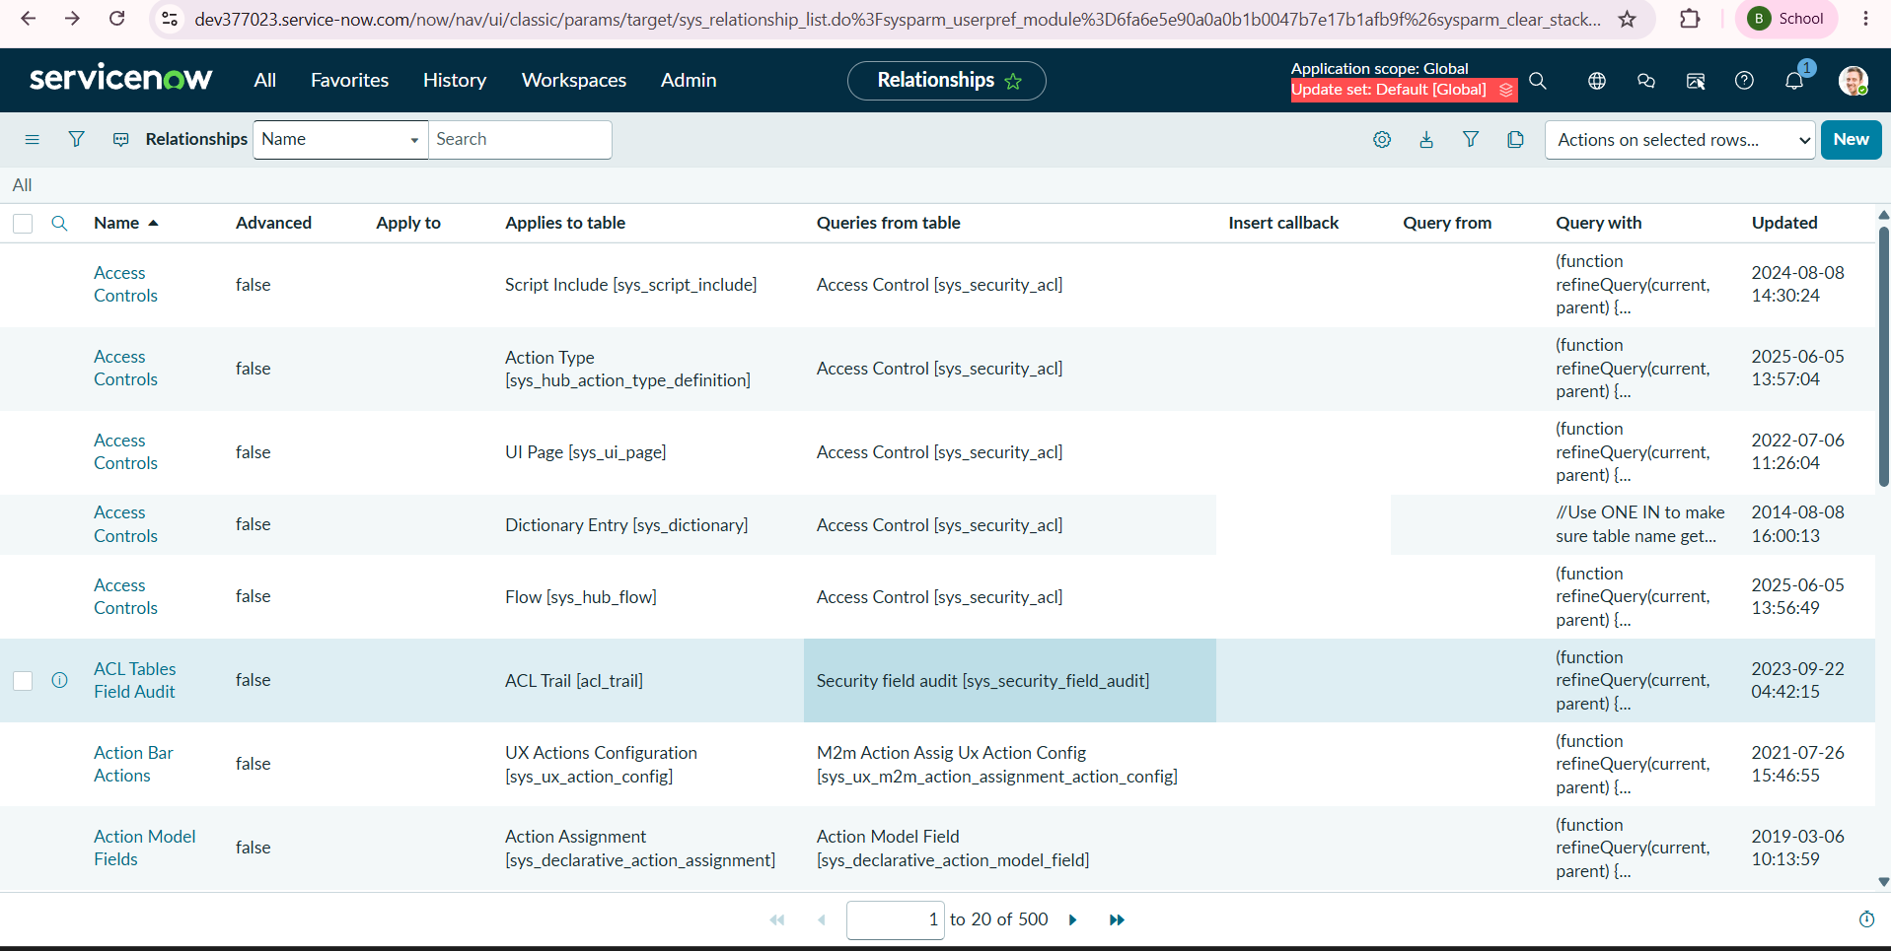
Capture the catalog item configuration showing:
- Name
- Catalog
- Category
- Short Description
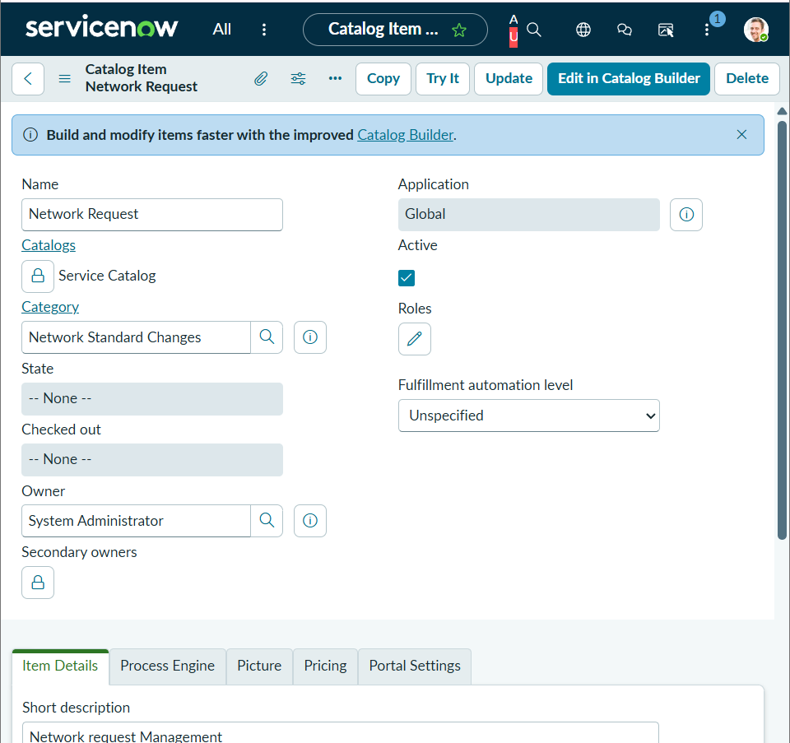
Outcome
The Network Request catalog item is created and is available as the foundation for the network request submission interface.

Activity 2 – Variables Configuration
What
Configure variables within the Network Request catalog item to collect information from the requester.
Why
Variables define the fields displayed to users when they submit the catalog item. Properly configured variables ensure that the request contains the information required for processing.
How
- Open the Network Request catalog item.
- Scroll to the Variables related list.
- Click New.
- Select the appropriate variable type, such as:
  - Single Line Text
  - Multi Line Text
  - Reference
  - Multiple Choice
- Enter the variable configuration.
Important properties include:
Property | Purpose
Order | Controls the sequence in which variables appear
Question | User-visible label
Name | Internal variable name used by scripts/automation
Tooltip | Provides additional information when the user hovers over the field
Example Text | Provides guidance about expected input
Mandatory | Requires the user to provide a value
Read-only | Prevents users from modifying the value
Auto-populate | Automatically retrieves information from another variable/record
- Configure the required properties.
- Click Save or Submit.
- Repeat the procedure for all required variables.


Capture one representative variable configuration showing properties such as Question, Name, Type, Order, Mandatory, and other relevant settings.
Outcome
The catalog item contains structured input fields that allow users to provide the information necessary to process their network request.

Activity 3 – Network Request Variables
What
Create the required variables for the Network Request catalog item.
Why
These variables capture the specific information required to process a network connection request and support subsequent automation.
Variable Configuration
S.No. | Variable Name | Type | Choices / Values
1 | Requested For | Single Line Text | —
2 | Mobile Number | Single Line Text | —
3 | Type of Connection | Multiple Choice | New / Existing
4 | Enter your Existing ID | Single Line Text | —
5 | Total Amount | Single Line Text | —
6 | Mode of Payment | Multiple Choice | UPI / CARD
7 | Address | Single Line Text | —
How
For each variable:
- Open the Network Request catalog item.
- Scroll to Variables.
- Click New.
- Enter the variable name/question.
- Select the appropriate Type.
- Configure choices where applicable.
- Set the appropriate Order.
- Configure Mandatory or Read-only as required.
- Save the variable.
- Repeat until all seven variables have been created.
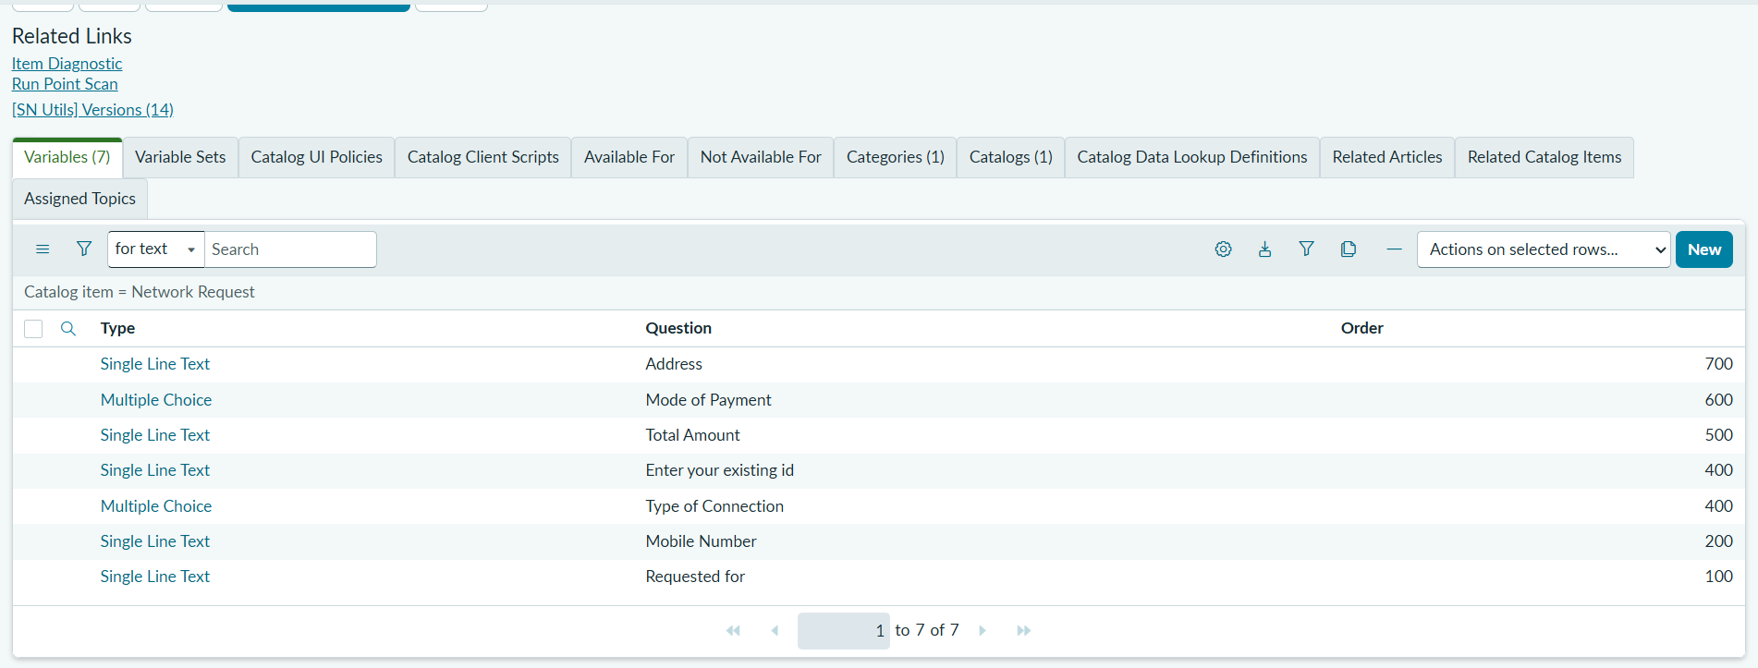
Outcome
The Network Request catalog item provides users with a standardized form for entering connection, requester, payment, and address information.

Activity 4 – Variable Set Configuration
What
Create a reusable Variable Set containing common requester information and associate it with the Network Request catalog item.
The variable set contains:
- Opened on behalf of
- Email ID
- User Name
- Phone Number
Why
Requester information is commonly required across service requests. Using a variable set makes the configuration reusable and reduces duplicate configuration across catalog items.
The auto-population capability also minimizes repetitive data entry and improves data accuracy.
How
Step 1 – Create the Variable Set
- Open the Network Request catalog item.
- Navigate to the Variable Sets related list.
- Click New.
- Create the required variable set.
- Save the variable set.
Step 2 – Create "Opened on behalf of"
Configure:
Property | Configuration
Variable Name | Opened on behalf of
Type | Reference
Reference | User [sys_user] table
This allows the user to select a ServiceNow user.
Step 3 – Create "Email ID"
Configure:
Property | Configuration
Variable Name | Email ID
Type | Single Line Text
Population | Auto-populate from Opened on behalf of
Step 4 – Create "User Name"
Configure:
Property | Configuration
Variable Name | User Name
Type | Single Line Text
Population | Auto-populate from Opened on behalf of
Step 5 – Create "Phone Number"
Configure:
Property | Configuration
Variable Name | Phone Number
Type | Single Line Text
Population | Auto-populate from Opened on behalf of
Auto-Population Concept
The relationship can be represented as:
Opened on behalf of
Reference
│
sys_user record
/ | \
Email ID User Name Phone Number
Auto Auto Auto
populated populated populated
The exact auto-population configuration should follow the fields available in your ServiceNow instance and the instructions/screenshots supplied by the capstone.
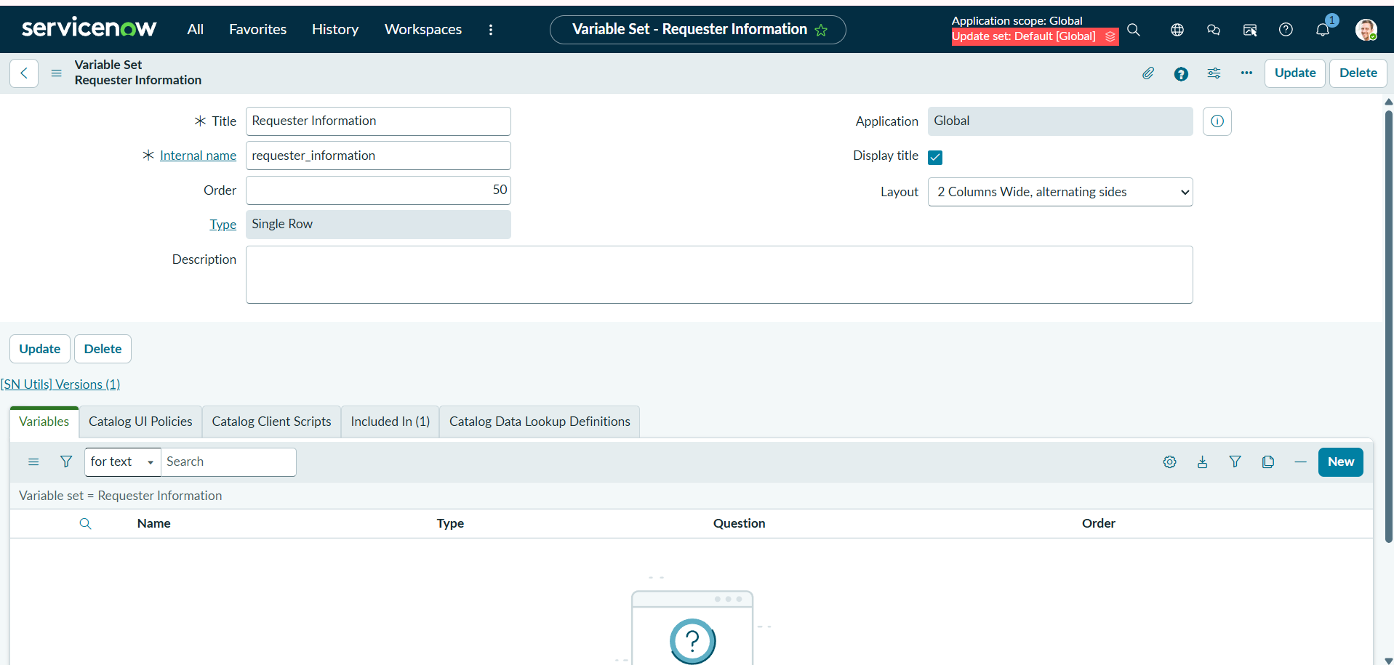

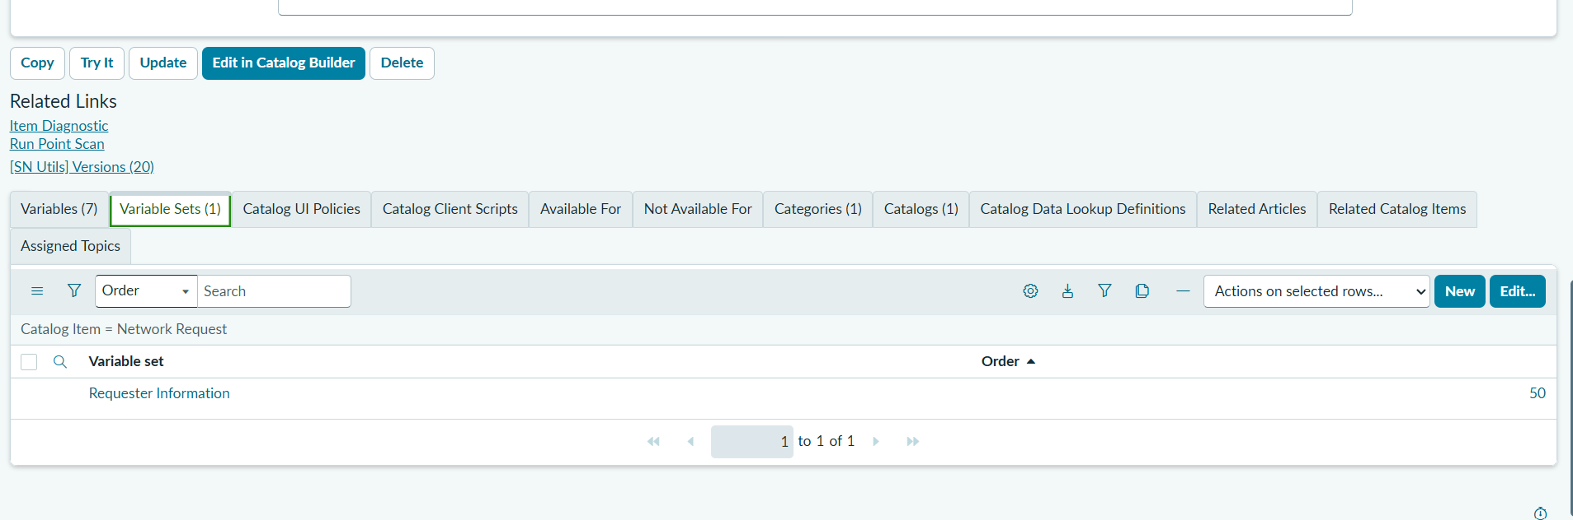
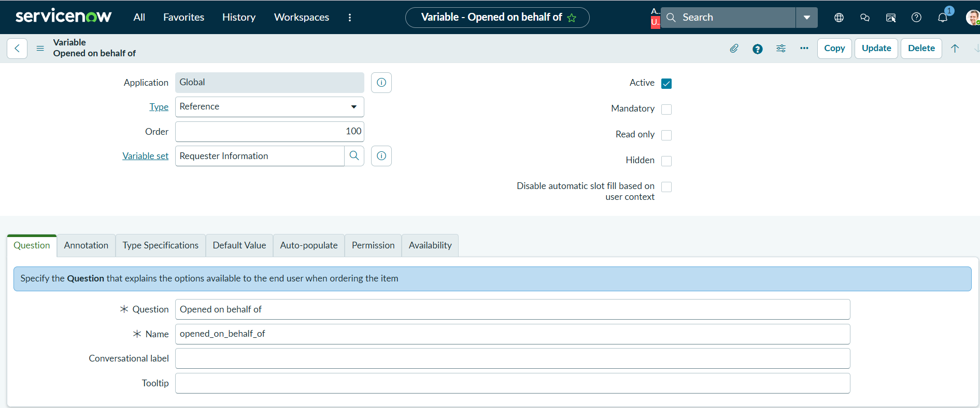

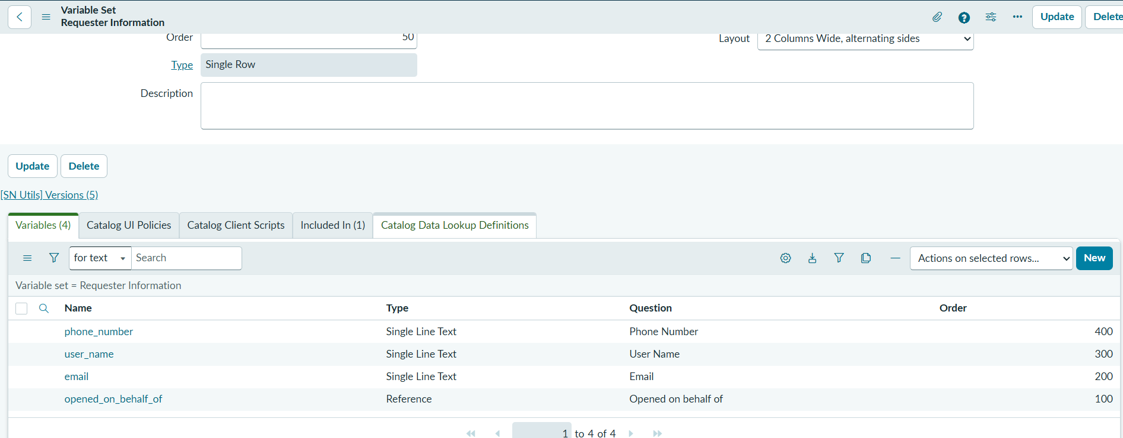



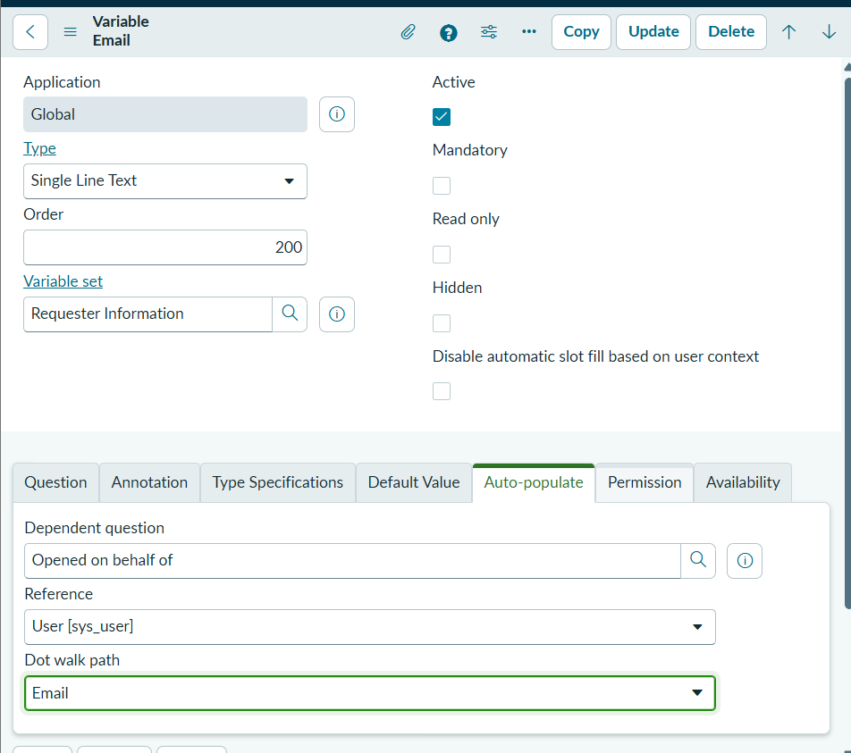
Outcome
The Interface Design phase establishes a standardized and user-friendly network request submission interface in ServiceNow.
After completing this phase:
- Users can access the Network Request catalog item.
- Required network-request information can be captured through variables.
- Connection type and payment mode provide predefined choices.
- Common requester information is maintained through a reusable variable set.
- User information can be automatically populated from the sys_user record.
- The resulting request contains structured information suitable for subsequent approval, workflow automation, fulfilment, and reporting.

Replicability Note
Note: When documenting the implementation, capture both the configuration screen and the resulting user-facing form. The configuration screenshot proves how the interface was built, while the final form screenshot demonstrates what the end user actually sees.

